# Enhancement of Project AEDES

Inception Report

Cirrolytix Research Services

**UNICEF Philippines and UNICEF Digital Public Goods Alliance**

January 2022

**Enhancement of Project AEDES** **1**

**Core Problem** **3**

**Milestones** **3**

**Expected Outcomes** **3**

**Risks** **4**

**Team Structure** **5**

**Project Activities** **5**

**Project Design** **6**

Milestone 1 Team Formation and Kickoff 6

Milestone 2 Automate data gathering 6

Milestone 3 Enhance nowcasting models 7

Milestone 4 Enhance mosquito hotspot detection model 7

Milestone 5 Web / mobile portal development and enhancement 7

Milestone 6 Implement INFORM Risk Framework 7

Milestone 7 Publication and dissemination 8

**Datasets** **8**

**Data Collection** **9**

**Licensing** **9**

**Technology Stack** **10**

**High Level Data Architecture** **11**

**Sustainability Plan** **12**

**Annex** **12**

Versions 12

# Core Problem

In 2019, the Philippine government declared a national epidemic as it struggled to contain its worst dengue outbreak since 2012. Total cases reached 420,453 and deaths at 1,565, 78% increase in infections and 33% in deaths from 2018. 42% of deaths are children between 5 and 9 years old (Relief Web, 2019) and 2 more kids die of dengue fever in Zambales (Inquirer, 2021).

With manual reporting, release of data is delayed which hampers the health sector’s ability to effectively deal with the threat. Prioritizing prevention is essential.

There is a risk that the dengue epidemic continues to take lives undetected. According to a study by Seposo, a decrease could be from reporting hesitancy due to fear of contracting COVID-19 in a health facility. COVID-19 may recede after mass vaccinations, however, dengue will continue to kill.

# Milestones

Milestone 1: Team Formation and Kickoff

Milestone 2: Automate data gathering

Milestone 3: Enhance nowcasting models

Milestone 4: Enhance mosquito hotspot detection model

Milestone 5: Web / mobile portal development and enhancement

Milestone 6: Implement INFORM Risk Framework

# Expected Outcomes

1. Data Collection and Processing - Database Management and Automated Data Ingest for Search Trends, Climate, Satellite, and Health Data which entails continuous research on alternate global open data sources.

2. Data Analysis - Incorporate Socio-Economic indicators using Dengue RISK INFORM in the predictive modeling and deploy to all regions. Enhancement of Dengue Case and Deaths Nowcasting.

3. Product Development - Redesign AEDES interface and functionalities which include information portals, publicly-accessible APIs, and near-real-time daily updates. This will entail Dengue Trends Overview, Outbreak/Epidemic Monitoring (time-series projections, dengue hotspot map visualizations), At-Risk Community Assessment (risk ranking of regions and provinces, risk maps), and Actions and Recommendations.

|  |  |
| --- | --- |
| **Output Type** | **Output Description** |
| Product | Project AEDES - Social Trends, Dengue Trends, Dengue Risk Indices and Mapping (1) |
| Publications | Research Paper (2) |
| Publications | Policy Paper (1) |
| People Services | Training for Researchers and Health Units (3) |
| Partnerships | LGUs (2) |

# Risks

|  |  |  |  |
| --- | --- | --- | --- |
| Risk (description) | Level of risk (high, low) | Probability (high, low) | Action planned to mitigate |
| Data (Timeliness, Accuracy) | High | Low | Reliance on credible 3rd parties (NASA, Landsat, ESA) |
| LHU Buy-in | Medium | Medium | Lobbying local government partnerships through UN system (UNDP, WHO, UNICEF) |
| Dedicated staffing due to reliance on volunteers | Medium | Low | Dedicated staffing costs to hire full time dedicated staff as part of the project (50% of funding) |

# Team Structure

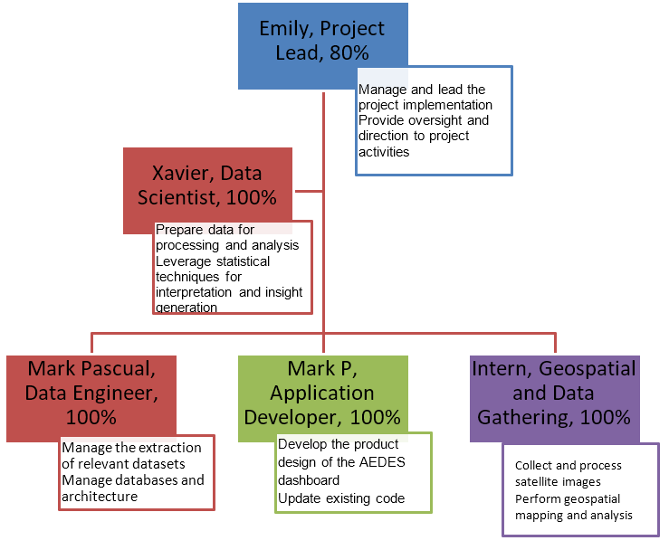

# Project Activities

|  |  |  |  |
| --- | --- | --- | --- |
| Month | Feature details | Status | Result |
| 1 month | API Development - Satellite (NDWI, NDVI, FAPAR)  from Sentinel HUB, Landsat, Euro Data Cube | Refining | Automated  data collection, repository, and feeder into application for remote sensing |
| Socio-economic Data |
| 1 month | Risk INFORM Framework and Model Integration | Developing | Risk modeling incorporating hazard,  vulnerability, and resilience indicators |
| 0.5 months | Social Listening - Google Trends, Twitter  Sentiments | Refinement | Automated data gathering of social indicators |
| 0.5 months | Dengue Trends Overview, Outbreak/Epidemic  Monitoring, At-Risk Community Assessment, Action and Recommendations | Refinement | Descriptive, Predictive, and Prescriptive  Modules |
| 0.5 months | Dengue case and deaths nowcast enhancement | Refinement | Show results of prediction including more  regions. |
| 1.5 months | UI/UX Enhancement | Refinement | Mobile Responsive Web-App |

# Project Design

## Milestone 1 Team Formation and Kickoff

Activity 1 Finalize team skill requirements

Activity 2 Role design

Activity 3 Promote job openings

Activity 4 Recruit team members

Activity 5 Onboarding and debriefing

## Milestone 2 Automate data gathering

Activity 1 Finalize automation requirements

Activity 2 Automation design - Remote Sensing

Activity 3 Automation design - google trends

Activity 4 Automation design - weather

Activity 5 Automation design - dengue cases and deaths

Activity 6 Implement automation - Remote Sensing

Activity 7 Implement automation - Google Trends

Activity 8 Implement automation - weather

Activity 9 Implmeent automation - dengue cases and deaths

Activity 10 Automation testing and evaluation

## Milestone 3 Enhance nowcasting models

Activity 1 Finalize nowcasting requirements

Activity 2 Nowcasting design

Activity 3 Data gathering - dengue cases and deaths

Activity 4 Data gathering - google trends

Activity 5 Data gathering - weather data

Activity 6 Nowcasting modeling - linear regression

Activity 7 Nowcasting modeling - time-series

Activity 8 Nowcasting modeling - SVM

Activity 9 Nowcasting testing and evaluation

Activity 10 Nowcasting model deployment

## Milestone 4 Enhance mosquito hotspot detection model

Activity 1 Finalize hotspot detection requirements

Activity 2 Hotspot detection design

Activity 3 Data gathering - remote sensing

Activity 4 Data gathering - ground observations

Activity 5 Hotspot modeling

Activity 6 Hotspot model testing and evaluation

Activity 7 Hotspot model deployment

## Milestone 5 Web / mobile portal development and enhancement

Activity 1 Finalize web and mobile portal requirements

Activity 2 Web and mobile portal design and wireframes

Activity 3 Web and mobile portal development

Activity 4 Web and mobile portal testing and evaluation

Activity 5 Web and mobile portal go-live

## Milestone 6 Implement INFORM Risk Framework

Activity 1 Finalize risk requirements

Activity 2 Risk framework design

Activity 3 INFORM inputs data gathering

Activity 4 Implement INFORM Risk Framework

Activity 5 Risk Framework testing and evaluation

Activity 6 INFORM model deployment

## Milestone 7 Publication and dissemination

Activity 1 Finalize publication requirements

Activity 2 Publication plan and design

Activity 3 Manuscript drafting and development

Activity 4 Editing and feedback

Activity 5 Publication

Activity 6 Webinar and training

# Datasets

Project AEDES relies on the following datasets as input data to the dashboard:

i. Google Trends Data

The raw values, ranging between 0-100, represent search interest as proportion of all searches of the inputted term for a given period of time and location. A value of 100 is the peak popularity of the term, 50 represents half of the popularity, and 0 means inadequate data.

Search data of related dengue words from Google Trends are collected at the regional level using dengue, dengue fever, dengue symptoms, dengue medicine, and dengue cure

ii. Disease Surveillance Data

Monthly reported dengue cases and deaths of the selected regions from 2015 to 2018 were obtained from the public records of disease surveillance released by the Department of Health on their website.

iii. Weather Data

Average rainfall and temperature were sourced out from the available weather stations of the DOST-PAG-ASA in the targeted areas. Data is available via an official request addressed to the Climatology and Agrometeorology Division (CAD) of DOST-PAGASA with a corresponding paid service fee.

iv. Satellite Data

Process Sentinel2 band satellite data using QGIS 3.4 to determine stagnant water locations in the specified city. The generated output is a CSV file which contains the coordinates of these potential Dengue hotspots computed from the FAPAR and NDWI of the satellite image.

# Data Collection

We have developed data extraction manuals for maintaining and updating the datasets through these link: https://github.com/Cirrolytix/aedes_dpg/wiki/D.-Explore-Updating-Datasets

● Satellite Data: Satellite imaging data from Sentinel Online Copernicus using QGIS

● Local Weather Data:

● Climate data from DOST-PAGASA

● Alternate weather indicators: Land Surface Temperature and Precipitation both of which are available from Terra/Aqua and Global Precipitation Measurement (GPM)

https://gpm.nasa.gov/data

https://lpdaacsvc.cr.usgs.gov/appeears/products

https://lpdaac.usgs.gov/tools/appeears/

● Google Data: Search trends for 'dengue' and related terms - automate extraction

● Disease Surveillance Data: Regional cases and deaths data from Department of Health

# Licensing

i. Satellite Data - Landsat 8 (NASA) and Sentinel-2 Copernicus (ESA) - Open Data

ii. Local Weather Data - DOST-PAGASA - Paid service

iii. Google Search Trends - Google https://policies.google.com/terms - Open Data

iv. Disease Surveillance Data - Department of Health - Open Government Data via Freedom of Information Bill

# Technology Stack

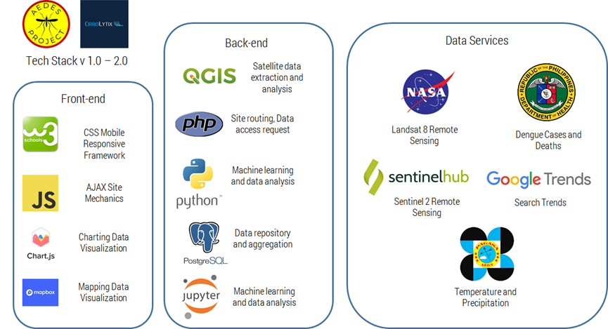

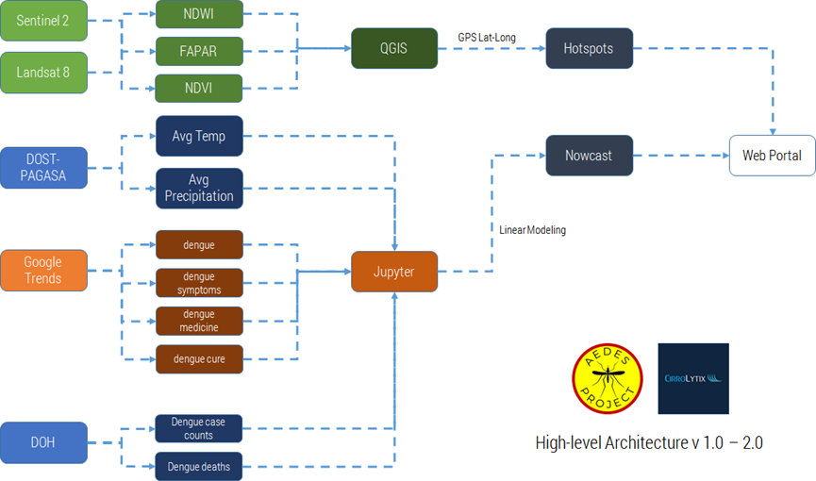

Front-end Stack

● W3-CSS - lightweight CSS framework for web-based and mobile-responsive front-end

● AJAX - Javascript asynchronous calls to back-end for data updates

● ChartJS - chart data visualization library

● MapboxJS - free tier of popular mapping library

Back-end Stack

● QGIS - open-source satellite API for remote sensing data extraction and analysis

● PHP - page routing and serving data access requests

● Python - perform machine learning (Scikit-Learn, STATS Models) and data analysis (Pandas)

● PostgreSQL - store and aggregate data

● Jupyter - data analysis and machine learning environment for Python

Data Sources

● NASA GIBS WMS - dynamically expose and visualize various satellite layers and indicators

● Sentinel HUB - access to and visualization of Sentinel satellite data

● Google Trends - access and extraction of public search interest

● DOH Epi Bureau - provision data on dengue cases and deaths

● DOST-PAGASA - provision data on average daily temperature and precipitation

# High Level Data Architecture

Sentinel 2 and Landsat 8 (NASA GIBS WMS/Sentinel HUB)

● Normalized Difference Water Index (NDWI), Fraction of Absorbed Photosynthetic Active Radiation (FAPAR), and Normalized Difference Vegetation Index (NDVI) extracted using QGIS

● Overlap of indicators provides data for mosquito hotspots which are ingested into Mapbox for visualization

DOST-PAGASA

● Provision CSV data on average daily temperature and precipitation

Google Trends

● Search interest on ‘dengue’, ‘dengue symptoms’, ‘dengue medicine’, and ‘dengue cure’

● Top search trends are visualized using ChartJS

DOH Epibureau

● Provision data on dengue case counts and deaths by region

Nowcasting

● Precipitation, temperature, and dengue search data were combined into a linear model to generate the nowcasts

● Nowcast data is visualized via Chart JS

# Sustainability Plan

The key improvements to the AEDES functionality are:

● Automation of data gathering from various sources, especially weather data which was sourced from an offline source (DOST-PAGASA)

● Enhancing the predictive modeling by adding additional ML algorithms to improve model fitting performance

● Incorporating the INFORM Epidemic Risk Framework with data gathered by AEDES teams to generate location-based risk maps, and advise policy interventions to mitigate the impacts of dengue

● Improvement of User Interface to make it feel more like a consumer utility e.g. Waze)

# Annex

## Versions

|  |  |  |  |
| --- | --- | --- | --- |
| Version | Main characteristics and features | Main changes from previous version | Reasons for changes made |
|  |
| Original 1.0 | NASA Space  Apps prototype | Covers: Quezon City, Iloilo City, Cotabato City,  Tacloban City | Original  design for hackathon |
| Linear Regression Fitting |
| NDWI+NDVI, NDWI+FAPAR hotspot detection |
| Version 1.1 | UX Enhancement - promotion model | Minor tweaks for UI development for  user-friendly demos, added w3.css template and improved mapbox layers | Improvements to the hackathon prototype after  the discussion with WHO Philippines and OpenStreetMaps |
| Version 1.2 | FTW  Prototype | Added CALABARZON Cities (Tagaytay, Cavite,  Batangas) | For The  Women Foundation Volunteers added new data to the repository |
| Added ARIMA and VAR models |
| Version 2 | Publication Model | Added information page, enhanced mapbox layers | Improved basic functionalities as part of  publishing the research paper on AEDES |
| Version 3 (in-progress) | Risk management model | Integration of INFORM epidemic risk framework  and learnings from existing work on COVID-19 surveillance | Generation of risk maps and more intuitive risk  recommendations |